**Best 10 London attractions 2022**

A trip to the capital wouldn't be complete without seeing the top 10 attractions in London. Visit now to enjoy these top things to do in London without the crowds.

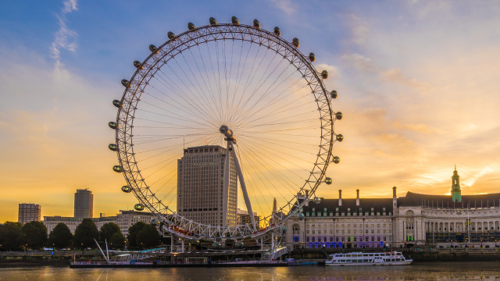The London Eye. Image courtesy of Shutterstock.

**landmarks, underwater, iconic,**

From the modern **London Eye**to the historic **Tower of London**, the top 10[**tourist attractions**](https://www.visitlondon.com/things-to-do/sightseeing/london-attraction) in London are a must-see on any London sightseeing trip. Even better, many London ………………………are free to visit. Use the **[Londo](https://www.visitlondon.com/things-to-do/london-attractions-map)**[n attractions map](https://www.visitlondon.com/things-to-do/london-attractions-map) to find them all.

There are also plenty of kid-friendly places to visit in London. Get up close and personal with creatures at [**SEALIFE London Aquarium**](https://www.visitlondon.com/things-to-do/place/117322-sea-life-london) or explore the Science Museum, London's interactive hub of science and technology. Both are perfect for fun family days out in London.

You could also soak up some culture at London museums, visit the Queen at [**Buckingham Palace**](https://www.visitlondon.com/things-to-do/place/427311-buckingham-palace), or take the perfect picture with Big Ben, just some of the many …………………places to go in London.

Thetop 10 free London attractions list is based on visitor numbers: start your sightseeing in London now with these popular spots. Book tickets with visit london.com for the top 10 bookable London attractions.

You may need to book tickets in advance, even if entrance is free.

* [**Top 10 bookable attractions**](https://www.visitlondon.com/things-to-do/sightseeing/london-attraction/top-ten-attractions#tab-0-0)
* [**Top 10 free attractions**](https://www.visitlondon.com/things-to-do/sightseeing/london-attraction/top-ten-attractions#tab-0-1)

[**Warner Bros. Studio Tour London**](https://www.visitlondon.com/things-to-do/place/23035130-warner-bros-studio-tour-london-the-making-of-harry-potter)

**[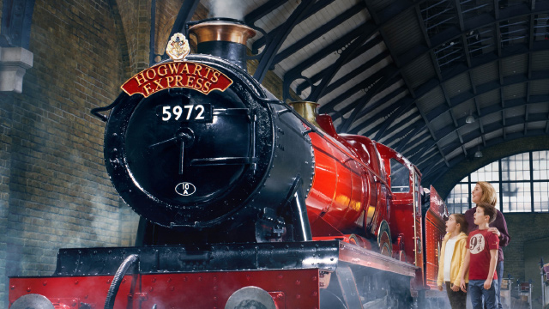](https://www.visitlondon.com/things-to-do/place/23035130-warner-bros-studio-tour-london-the-making-of-harry-potter)**

**relive, showcases,, spellbinding, wandering,**

Step on to authentic sets, discover the magic behind ……………………… special effects and explore the behind-the-scenes secrets of the Harry Potter film series.  
  
Discover the iconic Hogwarts Great Hall and explore the Forbidden Forest, all before boarding the original Hogwarts Express at Platform 9 ¾ and ……………………down Diagon Alley.  
  
Located at the Studios where all eight films were produced, the Studio Tour ……………………….the British talent, imagination and artistry that went into making the impossible a reality on screen. Visitors will…………………….. the magic through the eyes of the filmmakers who brought the Harry Potter film series to life.

**London Eye**

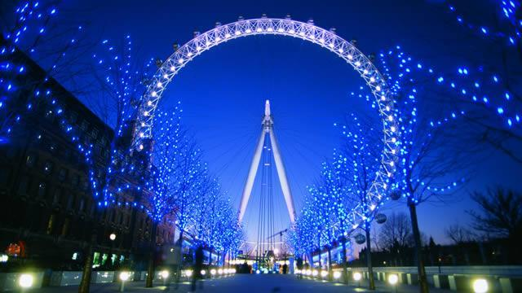

reconnect, mesmerizing, pods, cantilevered ,

Enjoy amazing 360-degree views over London from the lastminute.com **London Eye** - the world’s tallest ………………………observation wheel. The special engineering achievement has become a symbol of the modern capital and a world-famous icon of architecture. While riding the London Eye, you can see up to 40 km on a clear day and at an ……………………….135 metres (443 ft) high, you’ll be able to spot some of the capital's most iconic landmarks and  [**top attractions**](https://www.visitlondon.com/things-to-do/sightseeing/london-attraction/top-ten-attractions), including Big Ben, the Houses of Parliament and Buckingham Palace.

The London Eye has 32 pods, each representing one of London’s 32 boroughs and it is the perfect way to …………………………..with and experience the beautiful city of London.

**How long does it take to go around the London Eye?**

A leisurely rotation in one of the 32 high-tech glass ……………….takes approximately 30 minutes and gives you an ever-changing perspective of London. If you can’t wait to get up in the sky you can skip the queues with a fast-track entry ticket.

**Where is the London Eye and how do I get there?**

The London Eye is located on the south bank of the river Thames. The nearest station is **Waterloo**, but **Charing Cross**, **Westminster** and**Embankment** are also a short walk away. Several bus routes stop near the London Eye.

**How to book London Eye tickets**

Tickets to the London Eye **[must be pre-booked online](https://tickets.london/news/london-eye-ticket-options/2532)** with timed entry.

**London Transport Museum**

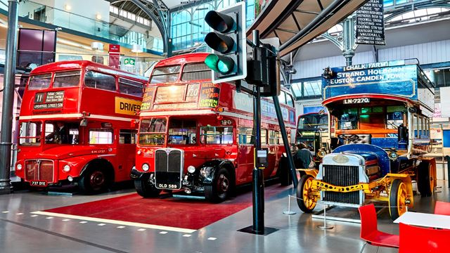Inside the London Transport Museum. Image courtesy of the London Transport Museum.

ground-breaking , intertwined,

Based in **Covent Garden**, the **London Transport Museum** showcases transport icons and …………………….design, from the red London bus to the first ever Tube map design.  
  
Explore how London’s growth, culture and society have been ……………………….with its transport system, from 1800 to today.

**What is there to see at the London Transport Museum?**

**carriage, roundel, featuring,**

Follow the evolution of **iconic vehicles**, spot the **world's first** **Underground steam train** and examine the **padded cell**, a train ……………dating back to the 1890s.  
  
Design lovers can marvel at the **Design for Travel** gallery, ……………………pioneering advertising posters and artworks. Spot Harry Beck's original design for his ground-breaking London Underground map and chart the development of the world-famous ………………….transport logo.  
  
Get hands-on at **interactive galleries**, where you can step aboard real buses and trains and have a go on a Tube driving simulator.  
  
If you’re keen to see more of the collection, visit the [**London Transport Museum Depot**](https://www.visitlondon.com/things-to-do/place/23654900-london-transport-museum-depot) in Acton on one of its open days.

**Emirates Air Line cable car**

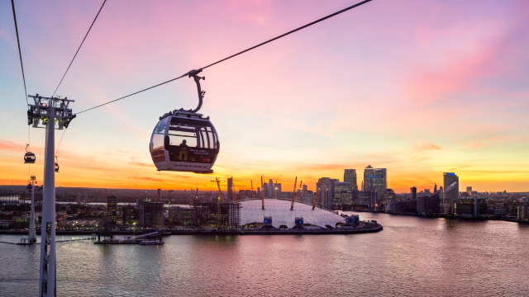

Emirates Air Line cable car. Image courtesy of Jon Reid.

Soak in magnificent views of London’s skyline as you travel above the river Thames, between Greenwich Peninsula and Royal Docks.

**About**

Glide above the Thames in the **Emirates Air Line cable car** and take in aerial views of London's skyline, as you travel from the **Greenwich Peninsula** to the **Royal Docks**.

**What can I see?**

Enjoy beautiful views of the Thames, London's skyline, the Greenwich Peninsula, the Royal Docks and The O2.

View sunset over the river and watch the city come alive after dark with extended night flights after 7pm.

**How much is the Emirates cable car?**

Save money by booking online. Book adult single tickets on the Emirates Air Line for £5 and child tickets for £2.50. Or book a round trip ticket, which costs £10 for adults and £5 for children.

[**Book Emirates Air Line cable car tickets now**](https://tickets.london/news/emirates-air-line-tickets/4497?_ga=2.64697320.695103822.1644221996-1090275322.1634544384).

**How long does the Emirates cable car journey take?**

The Emirates cable car journey times are adjusted according to passenger flow or weather conditions but usually take about 10 minutes.

**Where can I take the cable cars from/to?**

You can either catch the Emirates Air Line cable cars from North Greenwich or board on the Royal Victoria side of the river (return flights are available).

**What else can I do in the area?**

**heritage, marvels, eateries,**

[**Greenwich**](https://www.visitlondon.com/things-to-do/london-areas/greenwich) has centuries of history to explore, from royal ……………………… and attractions telling the story of astronomy and time, to world-class art and maritime ……………………….

Go back in time at the **Queen's House**and **Cutty Sark**; refuel at **Greenwich Market**or nearby ……………………..; and get your fill of shopping at **The O2**.

**HM Tower of London**

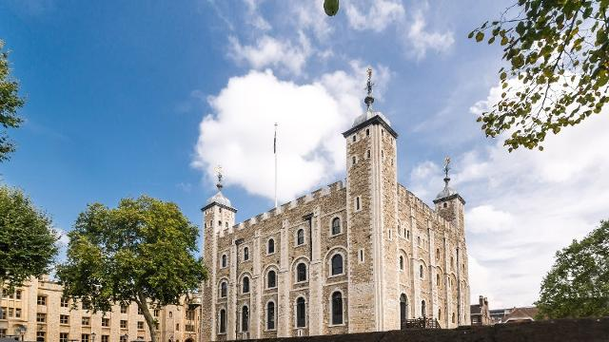HM Tower of London. Image courtesy of HM Tower of London.

**About**

fortress, infamous, evolve, ravens, moat, display,

Discover London's castle - a secure ………………….., royal palace and ………………….prison. Get up close to the Crown Jewels in the year of the Platinum Jubilee, meet the legendary Yeoman Warders and ………………….. and see the Tower like never before.  
  
Come and celebrate the Platinum Jubilee of Her Majesty The Queen at the Tower of London, where a spectacular, colourful, vibrant field of flowers will fill and transform the Tower's ………………. with Superbloom. From June to September, the flower ………………….. will ……………………. into new colours and patterns, creating a dramatic and engaging experience. Pre-booking essential.

**SEA LIFE London Aquarium**

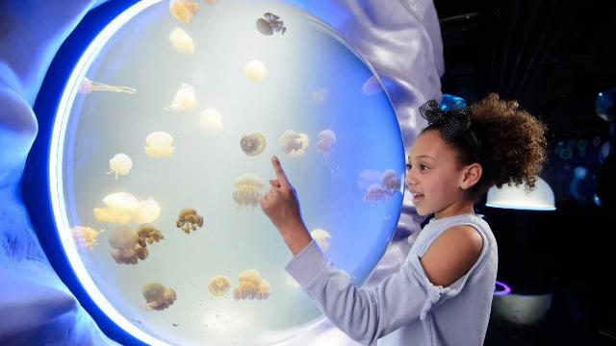SEA LIFE London

**About**

**underneath**

Explore the marine world at **SEA LIFE London Aquarium** on London's South Bank.

During your visit you'll stroll underneath the sea in the glass Ocean Tunnel; take a trip to Seahorse Kingdom; spot piranhas and crocodiles in the Rainforest Adventure and test your nerves on the Shark Walk as sharks swim beneath you.

Other creatures you'll meet include penguins, clownfish, rays, jellyfish and starfish.

**How long does it take to go around the London Aquarium?**

Most visits last between one and two hours.

**How to get to SEA LIFE London Aquarium**

The SEA LIFE London Aquarium is located in County Hall building on the south bank of the river Thames, next to the London Eye.

The nearest train station is [**Waterloo**](https://www.visitlondon.com/traveller-information/place/284464-london-waterloo-station) (also the nearest Tube station). You can also walk from Westminster or Charing Cross stations. Several bus routes serve the area with stops nearby.

**How to get London Aquarium tickets**

You must book tickets in advance to go to the London Aquarium. When booking you'll choose a date and 30-minute entry timeslot. **[Book London Aquarium tickets now*](https://tickets.london/news/sea-life-london-aquarium-ticket-options/3747)**.

The View from The Shard

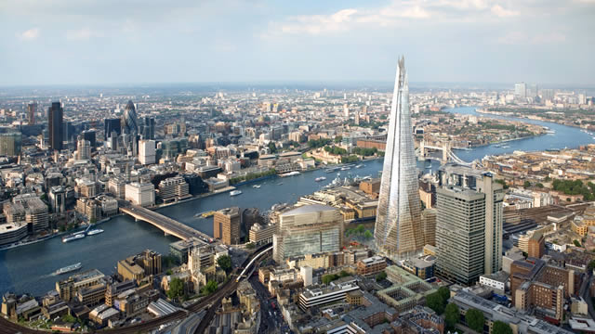London Bridge skyline

Soak up breathtaking views up to 40 miles (25km) across London from the top of one of the highest buildings in Europe at The View from The Shard.

**About**

Experience 360-degree views over London with a visit to **The View from The Shard**. At more than 1,000ft (300 metres) tall, The Shard in London Bridge is almost twice as high as any other building in the city.

**What to do at The View from The Shard**

**viewing, turns,**

The View from The Shard allows you to go inside The Shard building and look out over London from the …………………….. platforms on levels 68 and 69. You can also head up to the Skydeck on level 72 – an open-air platform offering spectacular views over London.

Top things to see from The View from The Shard include Tower Bridge, the twists and …………….. of the river Thames, Shakespeare's Globe Theatre and St Paul's Cathedral.

While you're enjoying the views, grab a drink or snack served by one of the bars. You can also book an all-inclusive experience in advance, which includes a glass of champagne and souvenir photos of your visit.

**Where is The View from The Shard?**

The View from The Shard is part of The Shard building, located just outside **London Bridge Station** – the main entrance can be accessed on Joiner Street.

The closest stations are London Bridge Underground Station (Northern and Jubilee Lines) and London Bridge Railway Station (Southern and Southeastern trains)



**Madam Tussauds**

**About**

**glamour, sculptors, swamp, villains,**

With 14 interactive areas, Madame Tussauds London combines glitz, ………………………..and incredible history with more than 300 stunning wax figures.  
  
Walk down the red carpet with Benedict Cumberbatch and Johnny Depp, before exploring our sports zone alongside Usain Bolt and David Beckham. Enjoy an audience with Her Majesty The Queen and Will and Kate before stepping on stage with music icons including Miley Cyrus. Then, after a behind-the-scenes look at how our …………………….. work, ride in a taxi and relive the rich history of London.  
  
Now you can delve into the world of Star Wars at Madame Tussauds London. Your favourite heroes and ……………………. from Star Wars Episodes I-VI have been brought to life in authentic walk-in sets, inspired by key scenes from the films, including the ………………………. of Dagobah, Jabba's Throne Room and the flight deck of the Millennium Falcon.